Variable length keyword arguments

Variable length keyword parameters are prefix with **
Variable length keyword parameter is of type dictionary
Variable length keyword parameter receives data as key and value pair.

Syntax:
def function-name(**parameter-name):
statement-1
statement-2

Example:
def fun1(**a):
print(a,type(a))

fun1(x=10,y=20,z=30)
fun1(rollno=1,name="naresh",course="python")
fun1()

Output
{'x': 10, 'y': 20, 'z': 30} <class 'dict'>
{'rollno': 1, 'name': 'naresh', 'course': 'python'} <class 'dict'>
{} <class 'dict'>

In application development keyword arguments are used to manipulate data by sending it as key and value pair (OR) to manipulate dictionary data.

Example:
def add(**kwargs):
total=0
for key,value in kwargs.items():
total=total+value
print(f'{key}={value}')
print(f"Sum of Values {total}")

add(a=10,b=20,c=30)
add(n1=100,n2=200,n3=300,n4=400,n5=500)

Output
a=10
b=20
c=30
Sum of Values 60
n1=100
n2=200
n3=300
n4=400
n5=500
Sum of Values 1500

Example:
def max_items(**kwargs):

max_item=None
for item in kwargs.items():
if max_item==None:
max_item=item
elif item[1]>max_item[1]:
max_item=item
return max_item

max_sales=max_items(jan=50000,feb=650000,mar=36000,apr=55000)
max_score=max_items(rohit=100,virat=70,surya=90)
print(max_sales)
print(max_score)

Output
('feb', 650000)
('rohit', 100)
Example:
def print_data(**kwargs):
for key,value in kwargs.items():
print(f'{key}\t{value}')

emp_dict={'naresh':45000,
'suresh':65000,
'ramesh':76000,
'kishore':32000}
print_data(**emp_dict)
stud_dict={'1':['naresh','python'],
'2':['suresh','java'],
'3':['ramesh','oracle']}
print_data(**stud_dict)

Output
naresh 45000
suresh 65000
ramesh 76000
kishore 32000
1 ['naresh', 'python']
2 ['suresh', 'java']
3 ['ramesh', 'oracle']

Example:
# defining order of multiple types of parameters
# 1. Required parameters
# 2. Default parameters
# 3. Variable length parameters
def fun1(a,b=None,*values,**kwargs):
print(a,values,kwargs,b)

fun1(10)
fun1(10,20,30,40,50)
fun1(10,x=100,y=200)
fun1(10,b=99)

Output
10 () {} None
10 (30, 40, 50) {} 20
10 () {'x': 100, 'y': 200} None
10 () {} 99

Nested Functions/Inner functions
Defining function inside function is called nested functions.

Why nested functions?
- Function hiding
- Developing special functions in python
  - Closures
  - Decorators
- Divide functionality of a function into sub functions.

Syntax:
def outer-function-name([parameters]):
def inner-function-name([parameters]):
statement-1
statement-2
statement-1
statement-2

Points to Remember
- Inner function is used within outer function but cannot accessible outside outer function.

def fun1():
print("outer function")
def fun2():
print("inner function")
fun2()

fun1()

Output
outer function
inner function

- Inner function can access local variables of outer function

def fun1():
x=100 #Local Variable
y=200 #Local Variable
def fun2():
print(x)
print(y)
fun2()

fun1()

Output
100
200

- Outer function cannot access local variables of inner function

def fun1():
def fun2():
x=100 # Local variable
y=200 # Local variable

print(x)
print(y)

fun1()

Output
File "D:/Backup/Python7PMOCT/test314.py", line 6, in fun1
print(x)
NameError: name 'x' is not defined

- Inner function can access local variables of outer function but cannot modify values directly

def fun1():
x=100 # Non Local
y=200 # Non Local
def fun2():
print(x)
print(y)
def fun3():
x=400 # Local Variable
y=500 # Local Variable
fun2()
fun3()
fun2()

fun1()

Output
100
200
100
200

- Inner function can modify or update values of outer function local variables using nonlocal keyword

nonlocal keyword

nonlocal keyword is used inside inner function to refer variables of outer function or outer block. Without nonlocal inner function cannot update or modify values of non local variables of outer function.

Syntax:
nonlocal variable-name,variable

After this statement, the given variable list refers to outer function.

def fun1():
x=100 # Non Local
y=200 # Non Local
def fun2():
print(x)
print(y)
def fun3():
nonlocal x,y
x=400
y=500
fun2()
fun3()
fun2()

fun1()

Output
100
200
400
500

LEGB

What is LEGB rule in python?
The LEGB rule is how Python determines the order in which it looks for a variable name when it's referenced in your code. It is an acronym for the four distinct scopes that Python checks sequentially: Local, Enclosing, Global, and Built-in

The Scope Resolution Order
When you use a variable name in your code, the Python interpreter follows this precise hierarchy to find the corresponding object:

L - Local: Python first checks the current, innermost scope. This includes variables defined within the current function or lambda expression. Function arguments also reside in the local scope.

E - Enclosing: If the name isn't found in the local scope, Python looks in the scope of any enclosing (outer) functions. This applies specifically to nested functions, allowing inner functions to access variables of their surrounding function.

G - Global: If the name is still not found, Python searches the global scope. This scope contains variables defined at the top level of your script or module, outside of any function or class.

B - Built-in: Finally, if the name is not found in any of the above scopes, Python checks the built-in scope. This is a special scope containing all of Python's pre-defined names, such as core functions like print(), len(), and standard exceptions.

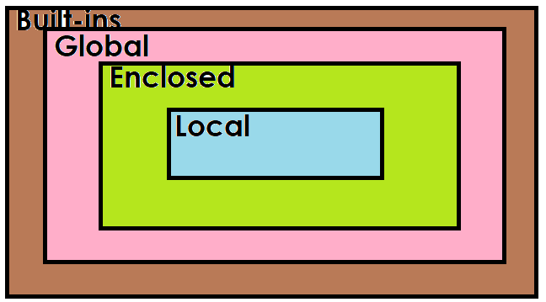
Example
x=100 # Global Variable
def fun1():
y=200 # Local Variable of fun1 and nonlocal of fun2
def fun2():
z=300 # Local variable
print(x)
print(y)
print(z)
print(__file__)

fun2()

fun1()

Output
100
200
300
D:/Backup/Python7PMOCT/test316.py

Example:
def calc(n1,n2,opr):
n3=None
def add():
nonlocal n3
n3=n1+n2
def sub():
nonlocal n3
n3=n1-n2
def multiply():
nonlocal n3
n3=n1*n2
def div():
nonlocal n3
n3=n1/n2
match opr:
case '+':add()
case '-':sub()
case '*':multiply()
case '/':div()
return n3

#main
while True:
num1=int(input("Enter First Number "))
num2=int(input("Enter Second Number "))
opr=input("Enter Operator ")
if opr not in "+-*/":
break
res=calc(num1,num2,opr)
print(f'{num1}{opr}{num2}={res}')

Output
Enter First Number 10
Enter Second Number 20
Enter Operator +
10+20=30
Enter First Number 5
Enter Second Number 4
Enter Operator *
5*4=20
Enter First Number 10
Enter Second Number 5
Enter Operator -
10-5=5
Enter First Number 5
Enter Second Number 2
Enter Operator **

